XÂY DỰNG CHƯƠNG TRÌNH ĐỔI TIỀN TỆ
- Chuẩn bị tài nguyên.
Mở ứng dụng Android Studio vào file chọn New Project chọn Empty View Activity Next.
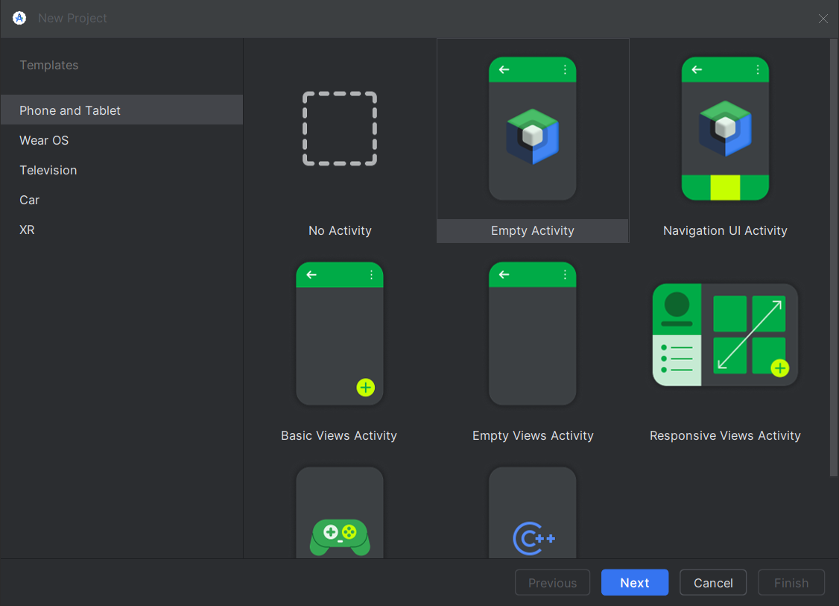
- Ở cửa sổ New project tiến hành đặt tên cho dự án chọn chọn nơi lưu dự án Finish để tạo dự án.
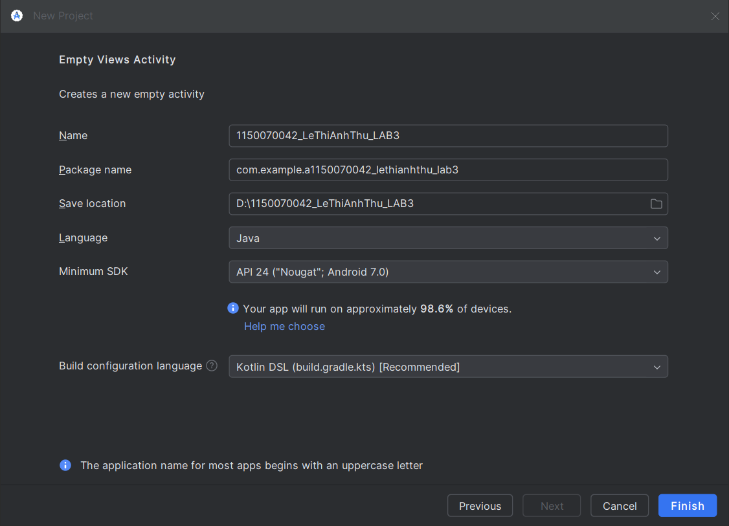
- Triển khai dự án
- Thêm Hình Ảnh Cờ (Flags).
+ Thêm hình ảnh Cờ vào Res/dawable/ bằng cách tải và kéo thẻ ảnh vào thư mục drawable. (lưu ý tên ảnh không được viết hoa).
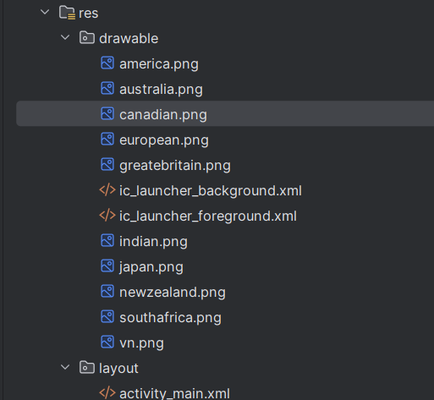
- Cần tạo các tài nguyên kiểu chuỗi trong file strings.xml như sau:
<resources>
<string name="author">Điền họ và tên của bạn</string>
<string name="computer">Điền tên máy đang dùng</string>
<string name="textbox_hint">Nhập số tiền</string>
<string name="app_name">Chương trình đổi tiền</string>
<string name="usd_name">American Dollar</string>
<string name="eur_name">European Cash</string>
<string name="gbp_name">Great Britain Pound</string>
<string name="inr_name">Indian Rupee</string>
<string name="aud_name">Australia Dollar</string>
<string name="cad_name">Canadian Dollar</string>
<string name="zar_name">South Africa Rand</string>
<string name="nzd_name">New Zealand Dollar</string>
<string name="jpy_name">Yên Nhật</string>
<string name="vnd_name">Việt Nam Đồng</string>
<string name="usd_unit">USD</string>
<string name="eur_unit">EUR</string>
<string name="gbp_unit">GBP</string>
<string name="inr_unit">INR</string>
<string name="aud_unit">AUD</string>
<string name="cad_unit">CAD</string>
<string name="zar_unit">ZAR</string>
<string name="nzd_unit">NZD</string>
<string name="jpy_unit">JPY</string>
<string name="vnd_unit">VNĐ</string>
</resources>

- Thiết Kế Giao Diện (activity_main.xml)
<?xml version="1.0" encoding="utf-8"?>
<LinearLayout
xmlns:android="http://schemas.android.com/apk/res/android"
xmlns:tools="http://schemas.android.com/tools"
android:layout_width="match_parent"
android:layout_height="match_parent"
android:orientation="vertical"
android:padding="16dp"
tools:context=".MainActivity">
<TextView
android:layout_width="wrap_content"
android:layout_height="wrap_content"
android:text="@string/app_name"
android:textSize="20sp"
android:textStyle="bold"
android:layout_gravity="center_horizontal"
android:layout_marginBottom="16dp"/>
<LinearLayout
android:layout_width="match_parent"
android:layout_height="wrap_content"
android:orientation="horizontal"
android:gravity="center_vertical"
android:paddingBottom="10dp"
android:baselineAligned="false">
<EditText
android:id="@+id/txtNumber"
android:layout_width="0dp"
android:layout_height="wrap_content"
android:layout_weight="1"
android:ems="10"
android:hint="@string/textbox_hint"
android:inputType="numberDecimal"
android:layout_marginEnd="8dp"/>
<Spinner
android:id="@+id/spnUnit"
android:layout_width="0dp"
android:layout_height="wrap_content"
android:layout_weight="1"/>
</LinearLayout>
<ScrollView
android:layout_width="match_parent"
android:layout_height="0dp"
android:layout_weight="1"
android:layout_marginTop="16dp">
<TableLayout
android:id="@+id/tl_currency_results"
android:layout_width="match_parent"
android:layout_height="wrap_content"
android:stretchColumns="*">
<TableRow style="@style/result_row_style_flag">
<ImageView style="@style/result_flag_style" android:src="@drawable/america" android:contentDescription="@string/usd_name"/>
<TextView style="@style/result_unit_label_style" android:text="@string/usd_unit"/>
<TextView android:id="@+id/lblUsd" style="@style/result_value_style_table" tools:text="100.00000"/>
</TableRow>
<TableRow style="@style/result_row_style_flag">
<ImageView style="@style/result_flag_style" android:src="@drawable/european" android:contentDescription="@string/eur_name"/>
<TextView style="@style/result_unit_label_style" android:text="@string/eur_unit"/>
<TextView android:id="@+id/lblEur" style="@style/result_value_style_table" tools:text="80.51800"/>
</TableRow>
<TableRow style="@style/result_row_style_flag">
<ImageView style="@style/result_flag_style" android:src="@drawable/greatbritain" android:contentDescription="@string/gbp_name"/>
<TextView style="@style/result_unit_label_style" android:text="@string/gbp_unit"/>
<TextView android:id="@+id/lblGbp" style="@style/result_value_style_table" tools:text="64.07000"/>
</TableRow>
<TableRow style="@style/result_row_style_flag">
<ImageView style="@style/result_flag_style" android:src="@drawable/indian" android:contentDescription="@string/inr_name"/>
<TextView style="@style/result_unit_label_style" android:text="@string/inr_unit"/>
<TextView android:id="@+id/lblInr" style="@style/result_value_style_table" tools:text="6333.18000"/>
</TableRow>
<TableRow style="@style/result_row_style_flag">
<ImageView style="@style/result_flag_style" android:src="@drawable/australia" android:contentDescription="@string/aud_name"/>
<TextView style="@style/result_unit_label_style" android:text="@string/aud_unit"/>
<TextView android:id="@+id/lblAud" style="@style/result_value_style_table" tools:text="121.82800"/>
</TableRow>
<TableRow style="@style/result_row_style_flag">
<ImageView style="@style/result_flag_style" android:src="@drawable/canadian" android:contentDescription="@string/cad_name"/>
<TextView style="@style/result_unit_label_style" android:text="@string/cad_unit"/>
<TextView android:id="@+id/lblCad" style="@style/result_value_style_table" tools:text="116.23600"/>
</TableRow>
<TableRow style="@style/result_row_style_flag">
<ImageView style="@style/result_flag_style" android:src="@drawable/southafrica" android:contentDescription="@string/zar_name"/>
<TextView style="@style/result_unit_label_style" android:text="@string/zar_unit"/>
<TextView android:id="@+id/lblZar" style="@style/result_value_style_table" tools:text="1171.29000"/>
</TableRow>
<TableRow style="@style/result_row_style_flag">
<ImageView style="@style/result_flag_style" android:src="@drawable/newzealand" android:contentDescription="@string/nzd_name"/>
<TextView style="@style/result_unit_label_style" android:text="@string/nzd_unit"/>
<TextView android:id="@+id/lblNzd" style="@style/result_value_style_table" tools:text="129.31000"/>
</TableRow>
<TableRow style="@style/result_row_style_flag">
<ImageView style="@style/result_flag_style" android:src="@drawable/japan" android:contentDescription="@string/jpy_name"/>
<TextView style="@style/result_unit_label_style" android:text="@string/jpy_unit"/>
<TextView android:id="@+id/lblJpy" style="@style/result_value_style_table" tools:text="11833.70000"/>
</TableRow>
<TableRow style="@style/result_row_style_flag">
<ImageView style="@style/result_flag_style" android:src="@drawable/vn" android:contentDescription="@string/vnd_name"/>
<TextView style="@style/result_unit_label_style" android:text="@string/vnd_unit"/>
<TextView android:id="@+id/lblVnd" style="@style/result_value_style_table" tools:text="21385.70"/>
</TableRow>
</TableLayout>
</ScrollView>
</LinearLayout>

- Đảm bảo file styles.xml của bạn có định nghĩa các style sau để căn chỉnh cờ chính xác:
<resources>
<style name="result_flag_style">
<item name="android:layout_width">40dp</item>
<item name="android:layout_height">25dp</item>
<item name="android:scaleType">fitCenter</item>
<item name="android:paddingEnd">10dp</item>
</style>
<style name="result_unit_label_style">
<item name="android:layout_width">wrap_content</item>
<item name="android:layout_height">wrap_content</item>
<item name="android:textSize">16sp</item>
<item name="android:textStyle">bold</item>
<item name="android:paddingEnd">10dp</item>
</style>
<style name="result_value_style_table">
<item name="android:layout_width">0dp</item>
<item name="android:layout_height">wrap_content</item>
<item name="android:layout_weight">1</item>
<item name="android:textSize">16sp</item>
<item name="android:gravity">end</item>
<item name="android:paddingEnd">16dp</item>
</style>
<style name="result_row_style_flag">
<item name="android:layout_width">match_parent</item>
<item name="android:layout_height">wrap_content</item>
<item name="android:paddingTop">8dp</item>
<item name="android:paddingBottom">8dp</item>
<item name="android:gravity">center_vertical</item>
<item name="android:background">#F5F5F5</item>
</style>
</resources>
- Nếu chưa có file style.xml hãy tạo trong thư mục res/layout/
- Xử lí logic trong MainActivity.java
package com.example.a1150070042_lethianhthu_lab3;
import android.os.Bundle;
import android.text.Editable;
import android.text.TextWatcher;
import android.view.View;
import android.widget.AdapterView;
import android.widget.ArrayAdapter;
import android.widget.EditText;
import android.widget.Spinner;
import android.widget.TextView;
import androidx.appcompat.app.AppCompatActivity;
import java.util.Locale;
public class MainActivity extends AppCompatActivity {
private EditText txtNumber;
private Spinner spnUnits;
private TextView[] lblResults;
private final String[] units = {
"USD", "EUR", "GBP", "INR", "AUD",
"CAD", "ZAR", "NZD", "JPY", "VNĐ"
};
private final double[][] ratio = {
{1.00000, 0.80518, 0.64070, 63.3318, 1.21828, 1.16236, 11.7129, 1.2931, 118.337, 21385.7},
{1.24172, 1.00000, 0.79575, 78.6084, 1.51266, 1.44314, 14.5371, 1.60576, 146.927, 26561.8},
{1.56044, 1.25667, 1.00000, 98.7848, 1.90091, 1.81355, 18.2683, 2.01791, 184.638, 33374.9},
{0.01580, 0.01272, 0.01012, 1.00000, 0.01924, 0.01836, 0.18493, 0.02043, 1.86910, 337.811},
{0.82114, 0.66119, 0.52620, 52.0860, 1.00000, 0.95416, 9.61148, 1.06158, 97.1120, 17567.9},
{0.86059, 0.69296, 0.55148, 54.5885, 1.04804, 1.00000, 10.0732, 1.11258, 101.777, 18401.7},
{0.08541, 0.06877, 0.05473, 5.40852, 0.10398, 0.09924, 1.00000, 0.11037, 10.0996, 1825.87},
{0.77402, 0.62319, 0.49597, 49.0031, 0.94215, 0.89951, 9.06754, 1.00000, 91.5139, 16552.1},
{0.00846, 0.00681, 0.00542, 0.53547, 0.01030, 0.00983, 0.09908, 0.01093, 1.00000, 180.837},
{0.00005, 0.00004, 0.00003, 0.00296, 0.00006, 0.00005, 0.00055, 0.00006, 0.00553, 1.00000}
};
private static final int VND_INDEX = 9;
@Override
protected void onCreate(Bundle savedInstanceState) {
super.onCreate(savedInstanceState);
setContentView(R.layout.activity_main);
txtNumber = findViewById(R.id.txtNumber);
spnUnits = findViewById(R.id.spnUnit);
lblResults = new TextView[units.length];
lblResults[0] = findViewById(R.id.lblUsd);
lblResults[1] = findViewById(R.id.lblEur);
lblResults[2] = findViewById(R.id.lblGbp);
lblResults[3] = findViewById(R.id.lblInr);
lblResults[4] = findViewById(R.id.lblAud);
lblResults[5] = findViewById(R.id.lblCad);
lblResults[6] = findViewById(R.id.lblZar);
lblResults[7] = findViewById(R.id.lblNzd);
lblResults[8] = findViewById(R.id.lblJpy);
lblResults[9] = findViewById(R.id.lblVnd);
ArrayAdapter<String> adapter = new ArrayAdapter<>(
this,
android.R.layout.simple_spinner_item,
units
);
adapter.setDropDownViewResource(android.R.layout.simple_spinner_dropdown_item);
spnUnits.setAdapter(adapter);
spnUnits.setOnItemSelectedListener(new AdapterView.OnItemSelectedListener() {
@Override
public void onItemSelected(AdapterView<?> parent, View view, int position, long id) {
convertCurrency();
}
@Override
public void onNothingSelected(AdapterView<?> parent) {}
});
txtNumber.addTextChangedListener(new TextWatcher() {
@Override
public void beforeTextChanged(CharSequence s, int start, int count, int after) {}
@Override
public void onTextChanged(CharSequence s, int start, int before, int count) {
convertCurrency();
}
@Override
public void afterTextChanged(Editable s) {}
});
convertCurrency();
}
private void convertCurrency() {
String inputStr = txtNumber.getText().toString().trim();
inputStr = inputStr.replace(',', '.');
if (inputStr.isEmpty() || inputStr.equals(".")) {
for (int i = 0; i < units.length; i++) {
if (lblResults[i] != null) {
lblResults[i].setText("0.00");
}
}
return;
}
double amount;
try {
amount = Double.parseDouble(inputStr);
} catch (NumberFormatException e) {
return;
}
int fromUnitIndex = spnUnits.getSelectedItemPosition();
for (int toUnitIndex = 0; toUnitIndex < units.length; toUnitIndex++) {
if (lblResults[toUnitIndex] == null) {
continue;
}
double exchangeRate = ratio[fromUnitIndex][toUnitIndex];
double result = amount * exchangeRate;
String formattedResult;
if (toUnitIndex == VND_INDEX) {
formattedResult = String.format(Locale.US, "%,.0f", result);
} else {
formattedResult = String.format(Locale.US, "%,.5f", result);
}
lblResults[toUnitIndex].setText(formattedResult);
}
}
}
- Kết quả đạt được:
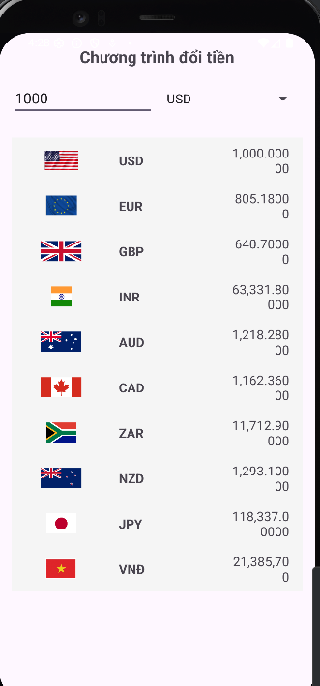

- XÂY DỰNG CHƯƠNG TRÌNH ĐỔI ĐỘ DÀI
Bước 1: Khai báo Tài nguyên Chuỗi (res/values/strings.xml)
- Cần định nghĩa các tên đơn vị và mã đơn vị (Unit Codes) cho 7 loại độ dài trong file strings.xml.
<string name="length_app_name">Chương trình đổi độ dài</string>
<string name="km_name">Kilometre</string>
<string name="hm_name">Hectometre</string>
<string name="m_name">Metre</string>
<string name="mile_name">Dặm (Mile)</string>
<string name="yard_name">Yard</string>
<string name="foot_name">Foot</string>
<string name="inch_name">Inch</string>
<string name="km_unit">KM</string>
<string name="hm_unit">HM</string>
<string name="m_unit">M</string>
<string name="mile_unit">Dặm</string>
<string name="yard_unit">Yard</string>
<string name="foot_unit">Foot</string>
<string name="inch_unit">Inch</string>

Bước 2: Thiết kế Giao diện (res/layout/activity_length_converter.xml)
Tạo một Layout mới có tên activity_length_converter.xml. Cấu trúc tương tự như phần đổi tiền, sử dụng EditText (txtNumber), Spinner (spnUnit), và TableLayout để hiển thị 7 kết quả.
<?xml version="1.0" encoding="utf-8"?>
<LinearLayout
xmlns:android="http://schemas.android.com/apk/res/android"
xmlns:tools="http://schemas.android.com/tools"
android:layout_width="match_parent"
android:layout_height="match_parent"
android:orientation="vertical"
android:padding="16dp"
tools:context=".LengthConverterActivity"> <TextView
android:layout_width="wrap_content"
android:layout_height="wrap_content"
android:text="@string/length_app_name" android:textSize="20sp"
android:textStyle="bold"
android:layout_gravity="center_horizontal"
android:layout_marginBottom="16dp"/>
<LinearLayout
android:layout_width="match_parent"
android:layout_height="wrap_content"
android:orientation="horizontal"
android:gravity="center_vertical"
android:paddingBottom="10dp"
android:baselineAligned="false">
<EditText
android:id="@+id/txtNumber"
android:layout_width="0dp"
android:layout_height="wrap_content"
android:layout_weight="1"
android:ems="10"
android:hint="@string/textbox_hint"
android:inputType="numberDecimal"
android:layout_marginEnd="8dp"/>
<Spinner
android:id="@+id/spnUnit"
android:layout_width="0dp"
android:layout_height="wrap_content"
android:layout_weight="1"/>
</LinearLayout>
<ScrollView
android:layout_width="match_parent"
android:layout_height="0dp"
android:layout_weight="1"
android:layout_marginTop="16dp">
<TableLayout
android:id="@+id/tl_length_results"
android:layout_width="match_parent"
android:layout_height="wrap_content"
android:stretchColumns="*">
<TableRow style="@style/result_row_style_table">
<TextView style="@style/result_unit_label_style" android:text="@string/km_unit"/>
<TextView android:id="@+id/lblKm" style="@style/result_value_style_table" tools:text="0.00000"/>
</TableRow>
<TableRow style="@style/result_row_style_table">
<TextView style="@style/result_unit_label_style" android:text="@string/hm_unit"/>
<TextView android:id="@+id/lblHm" style="@style/result_value_style_table" tools:text="0.00000"/>
</TableRow>
<TableRow style="@style/result_row_style_table">
<TextView style="@style/result_unit_label_style" android:text="@string/m_unit"/>
<TextView android:id="@+id/lblM" style="@style/result_value_style_table" tools:text="0.00000"/>
</TableRow>
<TableRow style="@style/result_row_style_table">
<TextView style="@style/result_unit_label_style" android:text="@string/mile_unit"/>
<TextView android:id="@+id/lblMile" style="@style/result_value_style_table" tools:text="0.00000"/>
</TableRow>
<TableRow style="@style/result_row_style_table">
<TextView style="@style/result_unit_label_style" android:text="@string/yard_unit"/>
<TextView android:id="@+id/lblYard" style="@style/result_value_style_table" tools:text="0.00000"/>
</TableRow>
<TableRow style="@style/result_row_style_table">
<TextView style="@style/result_unit_label_style" android:text="@string/foot_unit"/>
<TextView android:id="@+id/lblFoot" style="@style/result_value_style_table" tools:text="0.00000"/>
</TableRow>
<TableRow style="@style/result_row_style_table">
<TextView style="@style/result_unit_label_style" android:text="@string/inch_unit"/>
<TextView android:id="@+id/lblInch" style="@style/result_value_style_table" tools:text="0.00000"/>
</TableRow>
</TableLayout>
</ScrollView>
</LinearLayout>
- Cập nhật style.xml
<style name="result_row_style_table">
<item name="android:layout_width">match_parent</item>
<item name="android:layout_height">wrap_content</item>
<item name="android:paddingTop">8dp</item>
<item name="android:paddingBottom">8dp</item>
<item name="android:gravity">center_vertical</item>
<item name="android:background">#F5F5F5</item> </style>
Bước 3: Lập trình Logic (LengthConverterActivity.java)
- Tạo một class mới tên là LengthConverterActivity và viết code logic chuyển đổi.
package com.example.a1150070042_lethianhthu_lab3;
import android.os.Bundle;
import android.text.Editable;
import android.text.TextWatcher;
import android.view.View;
import android.widget.AdapterView;
import android.widget.ArrayAdapter;
import android.widget.EditText;
import android.widget.Spinner;
import android.widget.TextView;
import androidx.appcompat.app.AppCompatActivity;
import java.util.Locale;
public class LengthConverterActivity extends AppCompatActivity {
private EditText txtNumber;
private Spinner spnUnits;
private TextView[] lblResults;
private final String[] units = {
"Kilometre", "Hectometre", "Metre", "Dặm (Mile)", "Yard", "Foot", "Inch"
};
private final double[][] ratio = {
{ 1.0, 10.0, 1000.0, 0.621371, 1093.61, 3280.84, 39370.1 },
{ 0.1, 1.0, 100.0, 0.062137, 109.361, 328.084, 3937.01 },
{ 0.001, 0.01, 1.0, 0.00062137, 1.09361, 3.28084, 39.3701 },
{ 1.60934, 16.0934, 1609.34, 1.0, 1760.0, 5280.0, 63360.0 },
{ 0.0009144, 0.009144, 0.9144, 0.000568, 1.0, 3.0, 36.0 },
{ 0.0003048, 0.003048, 0.3048, 0.000189, 0.333333, 1.0, 12.0 },
{ 0.0000254, 0.000254, 0.0254, 0.00001578, 0.027778, 0.083333, 1.0 }
};
@Override
protected void onCreate(Bundle savedInstanceState) {
super.onCreate(savedInstanceState);
setContentView(R.layout.activity_length_converter);
txtNumber = findViewById(R.id.txtNumber);
spnUnits = findViewById(R.id.spnUnit);
lblResults = new TextView[units.length];
lblResults[0] = findViewById(R.id.lblKm);
lblResults[1] = findViewById(R.id.lblHm);
lblResults[2] = findViewById(R.id.lblM);
lblResults[3] = findViewById(R.id.lblMile);
lblResults[4] = findViewById(R.id.lblYard);
lblResults[5] = findViewById(R.id.lblFoot);
lblResults[6] = findViewById(R.id.lblInch);
ArrayAdapter<String> adapter = new ArrayAdapter<>(
this,
android.R.layout.simple_spinner_item,
units
);
adapter.setDropDownViewResource(android.R.layout.simple_spinner_dropdown_item);
spnUnits.setAdapter(adapter);
spnUnits.setOnItemSelectedListener(new AdapterView.OnItemSelectedListener() {
@Override
public void onItemSelected(AdapterView<?> parent, View view, int position, long id) {
convertLength();
}
@Override
public void onNothingSelected(AdapterView<?> parent) {}
});
txtNumber.addTextChangedListener(new TextWatcher() {
@Override public void beforeTextChanged(CharSequence s, int start, int count, int after) {}
@Override public void onTextChanged(CharSequence s, int start, int before, int count) {
convertLength();
}
@Override public void afterTextChanged(Editable s) {}
});
convertLength();
}
private void convertLength() {
String inputStr = txtNumber.getText().toString().trim().replace(',', '.');
if (inputStr.isEmpty() || inputStr.equals(".")) {
for (TextView lbl : lblResults) {
if (lbl != null) lbl.setText("0.00");
}
return;
}
double amount;
try {
amount = Double.parseDouble(inputStr);
} catch (NumberFormatException e) {
return;
}
int fromUnitIndex = spnUnits.getSelectedItemPosition();
for (int toUnitIndex = 0; toUnitIndex < units.length; toUnitIndex++) {
if (lblResults[toUnitIndex] == null) {
continue;
}
double exchangeRate = ratio[fromUnitIndex][toUnitIndex];
double result = amount * exchangeRate;
String formattedResult = String.format(Locale.US, "%,.5f", result);
lblResults[toUnitIndex].setText(formattedResult);
}
}
}
- Cập nhật Android Manifest để chạy Chương trình đổi độ dài
<activity
android:name=".LengthConverterActivity"
android:exported="true">
<intent-filter>
<action android:name="android.intent.action.MAIN" />
<category android:name="android.intent.category.LAUNCHER" />
</intent-filter>
</activity>

- Kết quả
